1. tail – Output the last part of files (useful for log monitoring)

Question 1: How do you continuously monitor the latest entries in a log file, such as /var/log/syslog ?

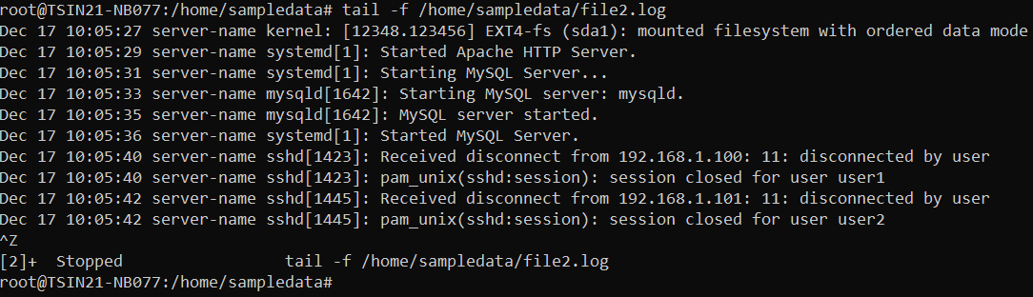

Question 2: How can you display the last 50 lines of a file instead of the default 10?

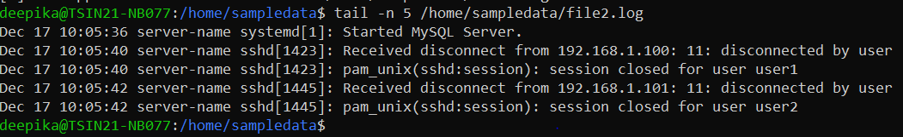

2. head – Output the first part of files

Question 1: How do you view the first 20 lines of a log file?

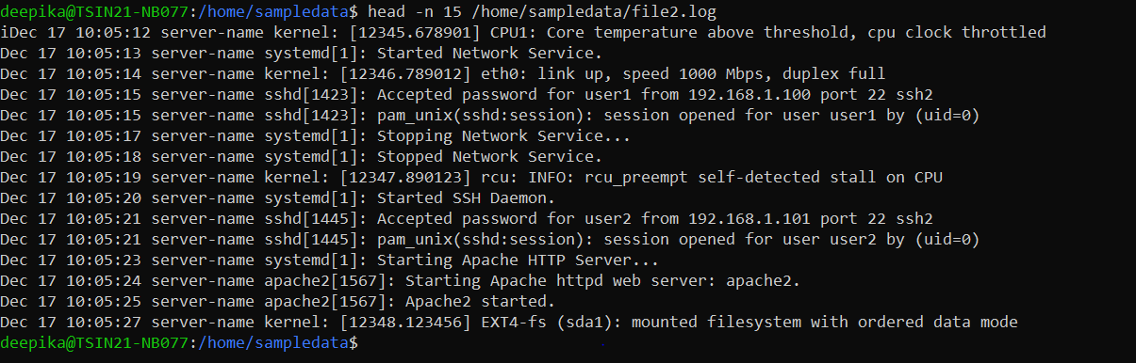

Question 2: How do you combine head and tail to extract lines 11 to 20 from a file?

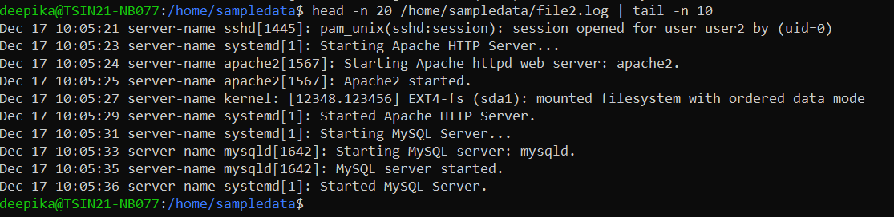

3. grep – Search file contents

Question 1: How do you find all log entries in /var/log/syslog containing the word “error”?

Question 2: How can you search for log entries case-insensitively?

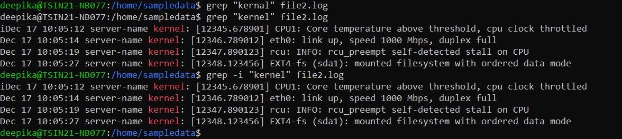

4. less – View file contents one page at a time

Question 1: How do you navigate a large log file one screen at a time?

Question 2: How can you search for the word “failed” within a file opened in less

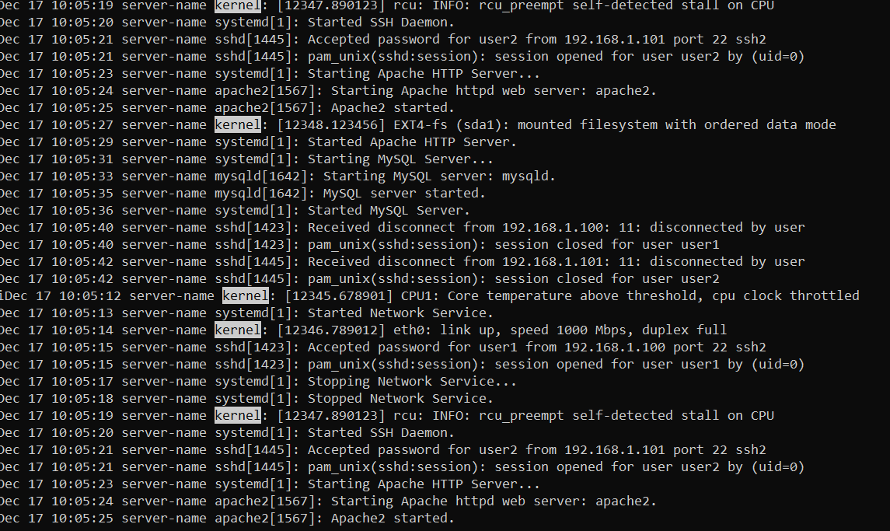

5. cat – Concatenate and display file contents

Question 1: How do you display the full contents of a log file in the terminal?

Question 2: How do you combine multiple log files and save the output to a new file?

1. Scenario 1: You want to monitor real-time logs of a web server to debug an issue.

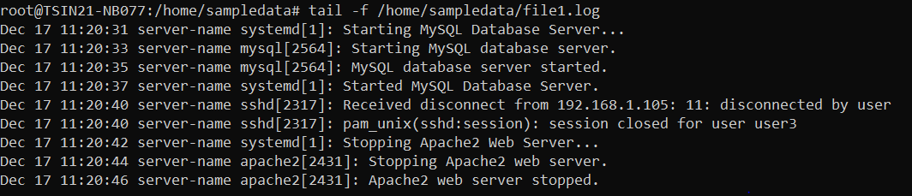

2. Scenario 2: A file is too large to open directly, and you want to quickly check the first and last 10 lines

